¡El Niño!-¡La Niña!
The ¡El Niño!-¡La Niña! is a slide chart that will help you explore the workings of the tropical Pacific marine environment. Stretching nearly one-third of the way around the globe and covering a fifth of the Earth’s surface, the tropical Pacific is a coupled ocean/atmosphere system that makes its presence known far beyond its boundaries. Its influence on world-wide weather and climate can lead to major ecological, societal, and economic disruptions. Occurrence of El Niño every two to seven years and the less frequent La Niña demonstrates that there are swings in ocean/atmosphere conditions, weather, and climate which operate on other than annual timetables.

With ¡El Niño!-¡La Niña!, you can investigate and compare ocean and atmospheric conditions that occur during El Niño and La Niña with long-term average (Neutral) conditions.
To Replace the above, watch the following animation of El Nino and La Nina:

https://www.youtube.com/watch?v=tyPq86yM_Ic

The Tropical Pacific During Long-Term Average Conditions

Examine ¡El Niño!-¡La Niña! with the slide insert pushed all the way into the device so that Neutral Conditions appears in the indentation along the bottom of the large window. (Note: If La Niña appears when fully inserted, pull the slide out, flip it to the other side, and reinsert.)

Look at the large window. It displays a schematic of the Pacific Ocean along the equator (greatly exaggerated in the vertical). The scene depicts the ocean surface with atmosphere above and a vertical cross-section of the ocean below. Note that numbered East longitudes occur to the west (left) of the International Dateline (180°) in the mid- Pacific while West longitudes occur to the east of the Dateline.

- Fair weather appears in the eastern tropical Pacific while [(fair)(stormy)] weather prevails in the western Pacific.

- Small windows depict conditions in the western, central, and eastern portions of the tropical Pacific. Dark blue triangles below the atmosphere windows and above the ocean windows point to the locations in the large window where conditions portrayed in the small windows are observed. The windows to your left represent a location in the [(eastern)(western)] tropical Pacific.

- The arrows in the Trade Winds windows point in the direction toward which the prevailing winds are blowing. The lengths of the arrows denote relative wind speeds; the longer the arrow, the greater the wind speed. As indicated in the windows, winds during neutral conditions blow toward the [(east)(west)] and the wind speed is [(higher)(lower)] in the eastern Pacific than in the western Pacific.

©American Meteorological Society

- The smaller windows below the large window provide ocean information. Arrows in the Surface Currents window indicate that during neutral conditions, surface water flows towards the [(east)(west)].

- According to the values reported in the windows, the highest sea surface temperatures (SSTs) during neutral conditions occur in the [(eastern)(western)] tropical Pacific. This SST pattern is caused by relatively strong Trade Winds pushing sun-warmed surface water [(eastward)(westward)], as evidenced by the direction of surface currents.

- Strong Trade Winds also cause the warm surface waters to pile up in the western tropical Pacific so that the sea surface height in the western Pacific is [(lower)(higher)] than in the eastern Pacific. Transport of surface waters to the west also causes the thermocline (the transition zone between warm surface water and cold deep water) to be [(deeper)(shallower)] in the eastern Pacific than in the western Pacific.

- Warm surface water transported by the wind away from the South American coast is replaced by cold water rising from below in a process called upwelling. Upwelling of cold deep water results in relatively [(high)(low)] SSTs in the eastern Pacific compared to the western Pacific.

- Cold surface water cools the air above it, which leads to increases in the surface air pressure. Warm surface water adds heat and water vapor to the atmosphere, lowering surface air pressure. As shown in the Surface Air Pressure windows, these effects result in tropical surface air pressure being [(highest)(lowest)] in the eastern Pacific and [(highest)(lowest)] in the western Pacific.

- Whenever air pressure changes over distance, a force will act on air to move it from where the pressure is relatively high to where pressure is relatively low. The Trade Winds blow from east to the west because from east to west the surface air pressure [(increases)(decreases)].

- Rainfall in the tropical Pacific is also related to SST patterns. There are reasons for this relationship. The higher the SST, the greater the rate of evaporation of seawater and the more vigorous is atmospheric convection. Consequently, during long-term average conditions, rainfall is greatest in the [(western)(eastern)] Pacific where SSTs are [(highest)(lowest)].

The Tropical Pacific During El Niño

Slowly pull the insert out of ¡El Niño!-¡La Niña! while watching the changing scene in the large window. Note that the stormy conditions move eastward. Continue pulling until the El Niño label is lined up in the lower left corner of the window. Now you are viewing atmospheric and oceanic conditions that are expected during a typical El Niño. While no

two El Niño episodes are exactly alike, all of them exhibit most of the characteristics described in ¡El Niño!-¡La Niña!.

- With the onset of El Niño, tropical surface air pressure patterns change. Compare the red El Niño readings in the western and central tropical Pacific windows with the black marks along the sides of the windows. The black marks indicate long-term average readings at those locations. During long-term average conditions, the surface air pressure in the central Pacific is higher than to the west. During El Niño, the surface air pressure to the west is [(higher)(lower)] than in the central Pacific. This seesaw pattern of pressure variation is called the Southern Oscillation.

- In response to changes in the air pressure pattern across the tropical Pacific, the speed of the Trade Winds decreases (and wind directions can reverse, especially in the western Pacific). No longer being pushed toward and piled up in the western Pacific, the warm surface water reverses flow direction. As seen in the Surface Currents window, the surface water currents during El Niño flow toward the [(east)(west)]. As evident in the appropriate Sea Surface Temperature window, this causes SSTs in the eastern tropical Pacific to be [(higher)(lower)] than neutral values.

- In response to surface currents, sea surface heights in the eastern tropical Pacific are [(higher)(lower)] than neutral levels. At the same time, the arrival of the warmer water causes the surface warm-water layer to thicken. Evidence of this is the [(shallower)(deeper)] depth of the thermocline compared to neutral conditions.

- Differences between existing conditions and neutral conditions are called anomalies. If El Niño readings are higher than the respective long-term averages (shown by the black reference lines next to the windows), the anomalies are positive. If El Niño values are lower, the anomalies are negative. In the eastern tropical Pacific during El Niño, the SST anomaly is [(negative)(positive)], the sea-surface height anomaly is [(negative)(positive)], the surface air pressure anomaly is [(negative)(positive)], and the rainfall anomaly is [(negative)(positive)].

The Tropical Pacific During La Niña

Remove the slide insert from the sleeve and turn it to the other side. Slide the insert back into the sleeve until Neutral Conditions appears in the indentation along the bottom of the large window. (Note that the Neutral Conditions on both sides of the insert are identical.) Then continue pushing the insert in until La Niña appears in the indentation.

- The stormy weather in the western Pacific has been displaced [(westward) (eastward)] from its Neutral Conditions position.

- During La Niña air pressure difference between the eastern and western Pacific is [(less)(greater)] than during Neutral Conditions (as shown by the black marks along the windows). The stronger trade winds are driven by an air pressure pattern that

[(increases)(decreases)] westward across the Pacific. The trade winds drive surface currents toward the [(west)(east)], resulting in sea surface temperatures in the western Pacific that are slightly [(higher)(lower)] than Neutral Conditions while the eastern Pacific experiences [(positive)(negative)] SST anomalies.

- The La Niña wind and current patterns produce a thermocline depth in the eastern Pacific that is [(deeper)(shallower)] than the long-term average value, leading to [(weaker)(stronger)] upwelling than average (note the large curved arrows).

Continue your investigations of the tropical Pacific ocean/atmosphere system by predicting how the changes shown by ¡El Niño!-¡La Niña! might impact people living along the Peruvian coast and on the island nations of the western tropical Pacific. Turn to the back of ¡El Niño!-¡La Niña! to study the potential impacts of El Niño in those areas and elsewhere, including the United States.

Extensions

- Satellites provide unique views of Earth's oceans. Imagery acquired by various sensors aboard these space platforms reveal broad-scale circulation patterns that can be seen in their entirety. Describe how each of the following remote sensors could be used to track the progress of El Niño: (a) infrared (IR) sensors that measure sea surface temperatures, (b) altimeters that monitor sea-surface height; and (c) ocean color sensors that observe visible light reflecting from pigments such as chlorophyll in phytoplankton.

- Not all observations of ocean conditions can be obtained remotely by sensors aboard satellites. Some measurements must be made "in situ," that is, by instruments actually in the water. Describe how each of the following unmanned platforms could be used to track the progress of El Niño: (a) tide gage stations that measure the height of local sea level, (b) moored buoys that monitor surface winds and water temperatures at several levels below the ocean surface, and (c) drifting buoys that observe the motion and temperature of surface ocean water.

- One of the best sources of data on ocean/atmosphere conditions are the sensors and scientists aboard oceanographic research ships. What are some of the advantages and disadvantages of using these resources to monitor El Niño?

- Reliable data obtained from remote and direct sensors help describe the existing conditions in the tropical Pacific. These data are now being used by scientists to develop realistic numerical models of the coupled ocean and atmosphere. Computers that are programmed with these models can project future states of the tropical ocean/atmosphere and foresee a future El Niño. What might be the value of such predictions?

Real World Applications
Following the intense El Niño episode of 1982-83 with its worldwide weather impacts, an instrumented array of buoys (Tropical Atmosphere Ocean (TAO) or TAO/TRITON array) was deployed across the tropical Pacific from ten degrees North latitude to ten degrees South latitude. Figure 1 is a map showing the buoy locations. This array, along with satellite observations, has allowed real-time monitoring of tropical Pacific ocean and atmosphere conditions and provided input for models used to predict future episodes.

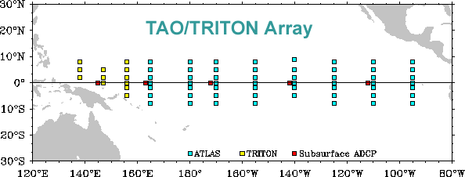

Figure 1. The locations of TAO-TRITON instrumented buoys in the tropical Pacific Ocean. [http://www.pmel.noaa.gov/tao/proj_over/map_array.html]

- An example of reporting of TAO surface data is presented in Figure 2. The upper panel of Figure 2 depicts the five-day mean tropical Pacific sea surface temperatures (SST) and wind conditions ending on December 28, 2011. The SST are shaded with isotherms drawn at one-half Celsius degree intervals. Wind directions are shown by arrows originating at the buoy site while the length of the arrow depicts the relative wind speed. The shading and isotherms indicate that the warmest waters across the tropical Pacific are located at about [(140° E)(180°)(140° W)] longitude. [Note, the Pacific east of 180° longitude (the International Dateline) has W(est) numbered longitudes while the Pacific west of 180° has E(ast) numbers.]

- Across most of the equatorial tropical Pacific, winds were flowing generally from
[(west to east)(east to west)].

The lower panel of Figure 2 displays Anomalies, that is, departures from the long-term average. Positive temperature anomaly isotherms are thin solid lines, negative anomaly isotherms are dashed lines. The anomaly interval between lines is also one-half degree Celsius. A bold solid line denotes the 0-degree departure (i.e. average).

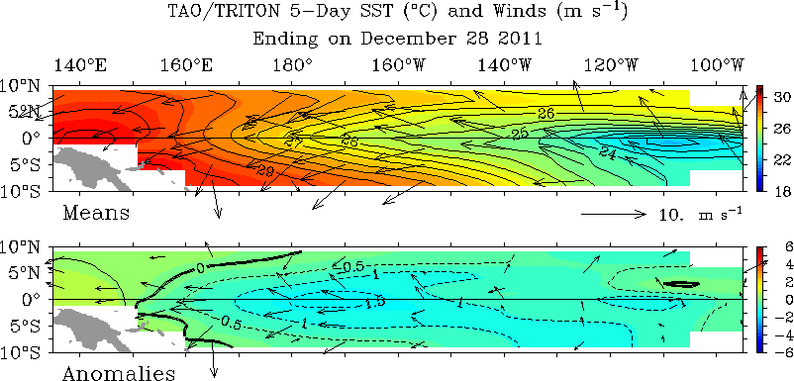

Figure 2. tropical Pacific conditions and anomalies on 28 December 2011.

- The broad pattern of current SST anomalies over the tropical Pacific region generally shows values that are essentially:
[(negative across most of the tropical Pacific) (positive across most of the tropical Pacific) (negative in the west and positive in the east)].

- The magnitudes of the greatest negative SST anomalies are more than
[(–1.5)(–2.5)(–3.5)] Celsius degrees.

Anomalous winds are departures from the average of both speed and direction. For example, the anomalous winds (lower panel) in the western tropical Pacific are also from east to west. That is, the departures are in the same direction with arrow lengths meaning greater actual speed than the long-term averages.

Now go to your ¡El Niño!-¡La Niña! slide chart. Compare the SST pattern anomalies seen in the small windows below the large central window and the Trade Winds arrows above the large central window in both the El Niño and the La Niña settings with the actual observed conditions and anomalies seen in Figure 2. Recall the SST anomalies in the western and eastern Pacific are given by the red and blue lines respectively of the small windows compared to the black indicator marks.

- The tropical Pacific conditions displayed in Figure 2 are most similar to those depicted in the ¡El Niño!-¡La Niña! chart occurring during a(n) [(El Niño)(La Niña)] event.

On September 8, 2011, NOAA’s Climate Prediction Center issued an advisory statement that La Niña conditions were strengthening and would continue through the Northern

Hemisphere winter of 2011-2012 (http://www.noaanews.noaa.gov/stories2011/20110908_lanina.html).

For more information on El Niño, see: http://www.pmel.noaa.gov/tao/elnino/el-nino- story.html and for La Niña, http://www.pmel.noaa.gov/tao/elnino/la-nina-story.html. For the latest Pacific conditions such as shown in Figure 2, go to: http://www.pmel.noaa.gov/tao/jsdisplay/.

